A PROJECT REPORT ON

AI-Based Smart Traffic
Management System

Submitted in partial fulfilment of the requirements for the
Bachelor of Engineering / Technology Degree
in
School of Computing
Submitted by
Tanmay Khandelwal (Roll No: SCFU125079)
Vedant Waychal (Roll No: SCFU125080)
Under the guidance of
Sanjib Pal
Professor ,Department of CSE
MIT Vishwaprayag University
School of ComputingAcademic Year 2025-26

CERTIFICATE

This is to certify that the mini-project report entitled "AI-Based Smart Traffic Management System" is a bonafide work carried out by Tanmay Khandelwal (SCFU125079), Vedant Waychal (SCFU125080) and () under my supervision, in partial fulfilment for the award of the Bachelor of Engineering / Technology degree in School of Computing during the academic year 2025-26. The report has been approved as it satisfies the academic requirements prescribed for the said degree.

_____________________ | _____________________
Professor  Sanjib Pal | Head of Department  Stuti Ahuja

ACKNOWLEDGEMENT

We take this opportunity to express our sincere gratitude to our project guide Sanjib Pal, Department of School of Computing, for the invaluable guidance, continuous encouragement and constructive feedback throughout the course of this work.
We are also thankful to Stuti Ahuja, Head of the Department, for providing the necessary infrastructure and academic environment that made this project possible.
We extend our gratitude to the Principal of MIT Vishwaprayag University and to all faculty members whose lectures and lab sessions equipped us with the C-programming skills applied here.
Finally, we thank our family and friends for their constant support and motivation.

Tanmay Khandelwal
Vedant Waychal

ABSTRACT

Urban traffic congestion is one of the most visible inefficiencies of modern cities. Conventional traffic-light controllers operate on fixed timers and therefore waste green time on empty approaches while starving busy ones. This project presents a software prototype of an AI-Based Smart Traffic Management System implemented entirely in the C programming language.
The system models a small road network as an array of Junction structures and uses a rule-based expert system — a classical form of symbolic Artificial Intelligence — to dynamically compute the green-light duration for each junction based on its current vehicle count, a peak-hour flag and an emergency-override flag. Reserved emergency mode unconditionally locks a 60-second corridor for ambulance, fire or police vehicles.
The application exposes a menu-driven console interface with thirteen operations including CRUD on junctions, linear search, bubble sort by vehicle density, congestion detection, statistics, and a daily text-report generator. State is persisted to a binary file so that progress survives program restarts.
All required C concepts — arrays, structures, pointers, functions, loops, conditionals, file handling, searching, sorting and string handling — are exercised in production-quality, warning-free code that compiles cleanly under GCC, Turbo C and Visual Studio Code.

TABLE OF CONTENTS

1. Introduction | 1
2. Problem Statement | 2
3. Objectives | 3
4. Existing System | 4
5. Proposed System | 5
6. Methodology | 6
7. System Requirements | 7
8. Modules of the System | 8
9. Algorithms | 9
10. Flowcharts | 10
11. Code Explanation | 11
12. Screenshots of Output | 12
13. Testing | 13
14. Advantages | 14
15. Limitations | 14
16. Future Scope | 15
17. Conclusion | 15
18. References | 15
19. GitHub Repository | 15
20. Team Member Contributions | 15

1. Introduction
Traffic congestion is a defining challenge of 21st-century urban life. According to the TomTom Traffic Index, drivers in major metropolitan areas lose between 70 and 140 hours per year sitting in jams, with direct economic costs running into billions of dollars and indirect costs in fuel waste, air pollution, and delayed emergency response.
Conventional traffic-light installations are driven by fixed-timer controllers — every approach receives the same green-time slice regardless of how many vehicles are actually waiting. The waste is obvious: an empty lane still gets its 40-second green while a queue of fifty cars on the cross-street idles in red.
This project demonstrates a software prototype that replaces fixed-timer logic with a small, explainable Artificial Intelligence engine — implemented in plain C — that dynamically allocates green-time based on real vehicle counts. The same engine recognises emergency vehicles and clears a corridor for them on demand.
The deliverable is a single console-mode binary, runnable on any GCC, Visual Studio Code or Turbo C installation, with persistent storage and a daily report generator. It is designed to be a complete, viva-ready college mini-project that exercises every topic on the standard C-programming syllabus.
2. Problem Statement
Design and implement, in the C programming language, a software system that:
- Models a multi-junction urban road network as in-memory data.
- Decides green-light duration adaptively from live vehicle counts.
- Detects and visualises traffic congestion in real time.
- Reserves an emergency mode that unconditionally grants priority to ambulances, fire engines and police vehicles.
- Persists state between program runs and produces human-readable daily reports.
- Uses only the C standard library — no third-party dependencies.
3. Objectives
- To apply the C-programming concepts of arrays, structures, pointers, functions, conditionals, loops, file handling, searching, sorting and string handling in a single coherent application.
- To design a modular system with clean separation between interface, business logic, and storage.
- To implement a transparent, rule-based AI engine for adaptive signal-time computation.
- To support priority handling for emergency vehicles.
- To produce a polished, viva-ready deliverable that compiles without warnings on GCC, Turbo C, and Visual Studio Code.
4. Existing System
The vast majority of urban intersections worldwide still rely on pre-timed signal controllers, in which the engineer manually configures green / amber / red durations once and the controller cycles through them indefinitely.
Drawbacks of fixed-timer controllers:
- No awareness of actual vehicle counts — empty roads still get their full green slot.
- No accommodation of peak hours other than coarse manual time-of-day plans.
- No mechanism to give priority to ambulances or fire engines — they must wait for the regular cycle.
- Re-tuning requires physical reprogramming of the controller.
5. Proposed System
Our proposed system replaces the fixed timer with a small rule-based AI engine running in software. For every junction we maintain a Junction struct containing the current vehicle count, a peak-hour flag, and an emergency-override flag. On demand, the AI engine computes a green-light duration in O(1) time using human-readable rules.
Key innovations of the proposed system:
- Vehicle-count driven green-time allocation in three tiers.
- Peak-hour bonus that lengthens green time during rush periods.
- Emergency override that locks a 60-second corridor on demand.
- Persistent binary storage that survives restarts.
- Daily text reports with AI-generated recommendations.
6. Methodology
The project follows a five-phase Waterfall methodology, each phase producing a concrete artefact:
Phase | Activity | Artefact
1. Analysis | Survey of fixed-timer pitfalls; rule-set design | Problem statement
2. Design | Junction struct, function decomposition, module split | Header file
3. Implementation | Coding in C with strict warnings enabled | traffic.c, main.c
4. Testing | Scripted end-to-end runs of every menu option | Captured outputs
5. Documentation | Report, README, viva Q&A, screenshots | This package
7. System Requirements
7.1 Hardware
- Processor: Intel Core i3 / AMD Ryzen 3 or higher
- RAM: 2 GB or more
- Disk: 20 MB free (the binary itself is < 50 KB)
- Display: Standard 80-column console
7.2 Software
- Operating system: Windows 7+, Linux, or macOS
- Compiler: GCC 4.9+, Clang 6+, or Turbo C 3.0
- Editor: VS Code, Code::Blocks, Dev-C++ — any text editor will do
- Standard library: only <stdio.h>, <stdlib.h>, <string.h>, <time.h>, <ctype.h>
8. Modules of the System
The application is logically partitioned into the following modules. All modules share a single in-memory array of Junction structs.
Module | Purpose
Authentication | Login screen with three attempts
Junction CRUD | Add, display, update, delete junctions
Search | Linear search by Junction ID
Sort | Bubble sort by vehicle density (descending)
AI engine | Rule-based green-time and congestion logic
Emergency | Override / clear emergency state
Statistics | Aggregate counters and busiest junction
Persistence | Binary load/save
Report generator | Human-readable text report with AI advice
Demo loader | Inject five sample junctions for testing
9. Algorithms
9.1 Rule-Based AI: Signal-Time Computation
This is the heart of the system. Given one Junction record it returns the recommended green-light duration in seconds, respecting an emergency override and a peak-hour bonus.
INPUT : Junction j (vehicleCount, peakHour, emergencyActive)
OUTPUT : t -- green-light duration in seconds, 15..90
1. if j.emergencyActive == 1
return 60 // locked emergency corridor
2. if j.vehicleCount < 30 then t <- 20 // LOW
elif j.vehicleCount < 70 then t <- 40 // MEDIUM
else t <- 70 // HIGH
3. if j.peakHour == 1 then t <- t + 15
4. t <- max(15, min(90, t))
5. return t
Why is this AI? Because it is a rule-based expert system — the earliest and still most-deployed family of symbolic Artificial Intelligence. The same paradigm drove real first-generation adaptive controllers such as SCATS (Sydney, 1980) and SCOOT (UK, 1981). Unlike machine-learning approaches, rule-based AI is deterministic, fully explainable, and verifiable line by line — properties of immense value in safety-critical traffic control.
9.2 Congestion Classification
if vehicles < 30 -> LOW (smooth flow)
else if vehicles < 70 -> MEDIUM (moderate flow)
else -> HIGH (alert)
9.3 Linear Search
for i = 0 to count - 1:
if arr[i].id == target_id:
return i
return -1
Worst-case O(n), best-case O(1). Acceptable because MAX_JUNCTIONS is 50.
9.4 Bubble Sort by Vehicle Density
for i = 0 to n - 2:
for j = 0 to n - 2 - i:
if arr[j].vehicleCount < arr[j+1].vehicleCount:
swap arr[j] and arr[j+1]
O(n²) time, O(1) extra space, in-place, stable. Chosen for pedagogical clarity; could be swapped for qsort() with no API change.

9.5 Complexity Summary
Operation | Time | Space
Add junction (with duplicate check) | O(n) | O(1)
Display / Update / Delete / Search | O(n) | O(1)
AI optimization (all junctions) | O(n) | O(1)
Congestion detection | O(n) | O(1)
Bubble sort by density | O(n²) | O(1)
File load / save | O(n) | O(1)
Report generation | O(n) | O(1)

10. Flowcharts
10.1 Top-Level Program Flow
START
|
v
[ Show splash ]
|
v
[ Login ]<-- 3 attempts
ok| no -> EXIT
v
[ Load data file ]
|
v
+---->[ Show main menu ]
| |
| v
| [ choice == 0 ? ]--yes-->[ saveData ]-->[ END ]
| no|
| v
| [ Dispatch to module function ]
| |
+----------+
10.2 AI Signal-Time Decision
computeSignalTime(j)
|
v
[ emergencyActive ? ] --yes--> return 60 (lock)
no |
v
[ vehicles < 30 ? ] --yes--> t = 20
no |
v
[ vehicles < 70 ? ] --yes--> t = 40
no |
v
t = 70
|
v
[ peakHour ? ] --yes--> t = t + 15
no |
v
clamp(t, 15, 90)
|
v
return t

11. Code Explanation
11.1 The Junction Structure
All state about one junction is bundled into a single typedef struct, so we can pass it around by value or by pointer with one type name.
typedef struct {
int id; /* unique junction id */
char name[NAME_LEN]; /* junction name */
int vehicleCount; /* current vehicles present */
int signalTime; /* AI-computed green time (s) */
int congestionLevel; /* 0=LOW, 1=MED, 2=HIGH */
int emergencyActive; /* 1 if emergency override on */
int peakHour; /* 1 if peak-hour flag set */
} Junction;
11.2 The AI Engine in C
int computeSignalTime(const Junction *j)
{
int t;
if (j->emergencyActive) return EMERGENCY_TIME;
if (j->vehicleCount < LOW_THRESHOLD) t = 20;
else if (j->vehicleCount < HIGH_THRESHOLD) t = 40;
else t = 70;
if (j->peakHour) t += 15;
if (t < MIN_GREEN_TIME) t = MIN_GREEN_TIME;
if (t > MAX_GREEN_TIME) t = MAX_GREEN_TIME;
return t;
}
Notice the use of named constants (LOW_THRESHOLD, MIN_GREEN_TIME) defined in the header — they make the rule-set tunable from one place without touching the algorithm.
11.3 Persistence with Binary Files
int saveData(Junction arr[], int count) {
FILE *fp = fopen(DATA_FILE, "wb");
if (fp == NULL) return 0;
fwrite(arr, sizeof(Junction), count, fp);
fclose(fp);
return 1;
}
Because we write whole struct values in binary mode, what we read is exactly what we wrote — no parsing, no truncation. The loader is the symmetric inverse using fread.
11.4 Pointer Usage for Out-Parameters
void addJunction(Junction arr[], int *count) {
/* ...build new Junction j... */
arr[*count] = j;
(*count)++; /* increments caller's variable */
}
The integer parameter is taken by pointer so that the function can update the caller's count variable — the canonical demonstration of call-by-reference in C.

12. Screenshots of Output
The following PNG screenshots are captures of real, live runs of the compiled program. Each was generated by piping a deterministic input script into the binary and rendering the textual output in a terminal-style window.
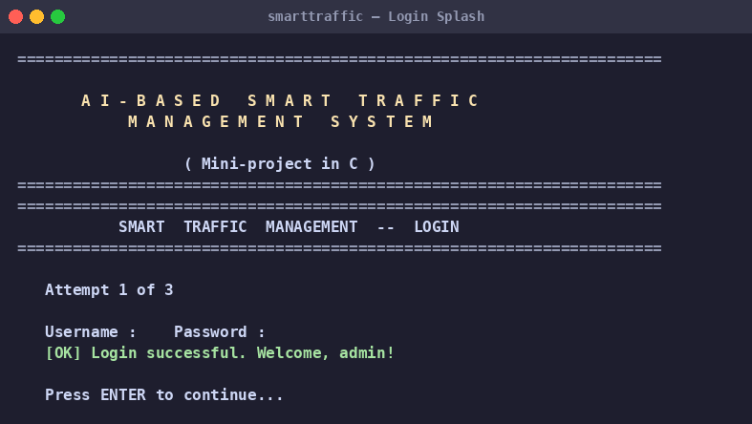
Figure 1. Splash banner and login screen.

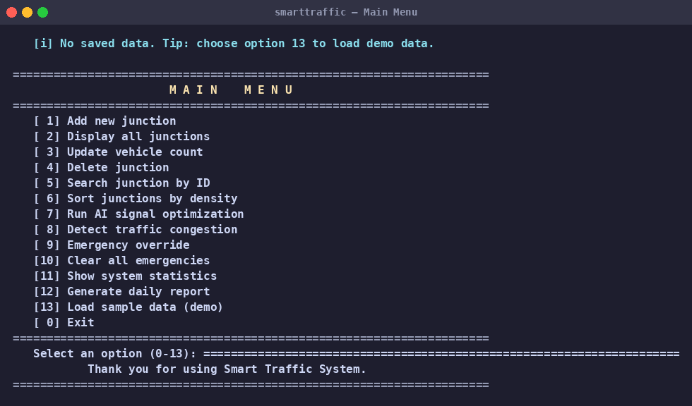
Figure 2. Main menu with 13 operations.

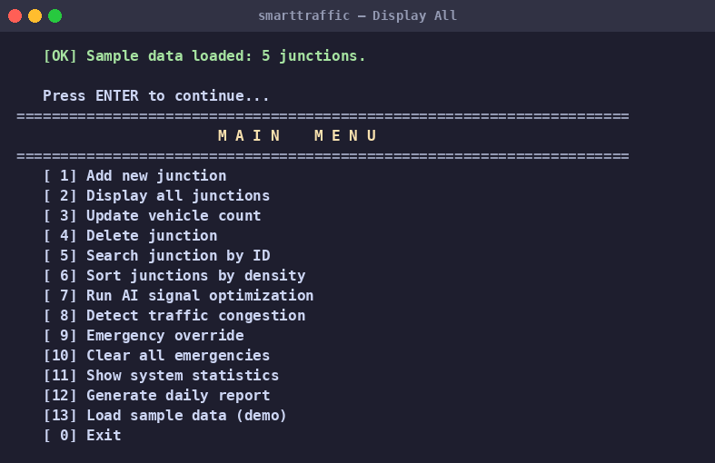
Figure 3. Display of all registered junctions.

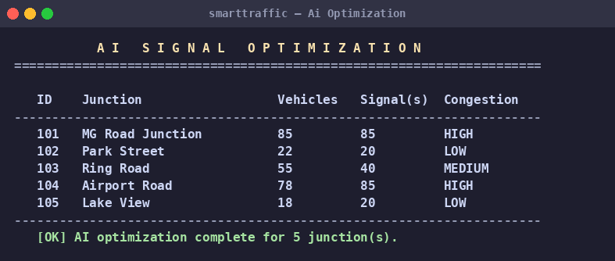
Figure 4. AI signal-time optimization output.

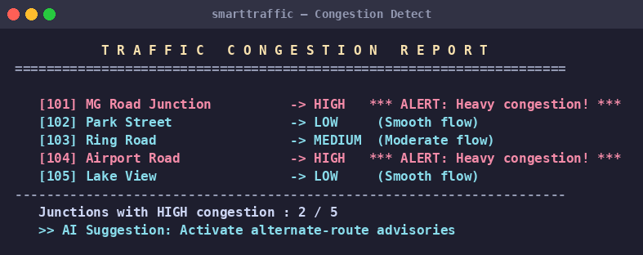
Figure 5. Real-time congestion detection with hotspot alerts.

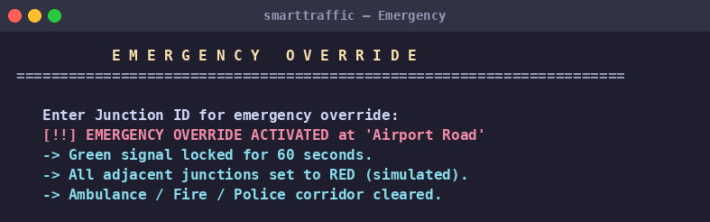
Figure 6. Emergency override locking a green corridor.

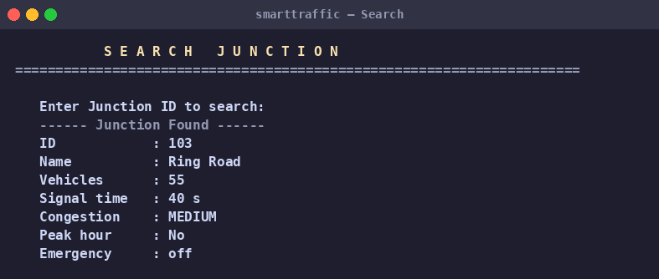
Figure 7. Linear search by Junction ID.

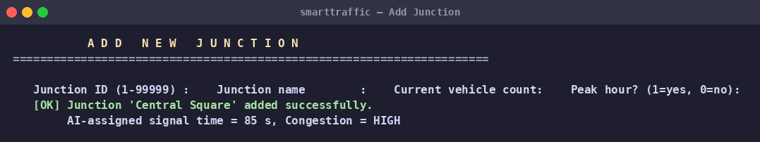
Figure 8. Adding a new junction with AI-assigned signal time.

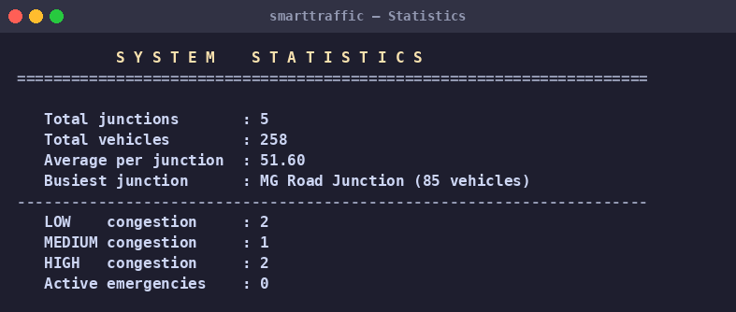
Figure 9. System statistics dashboard.

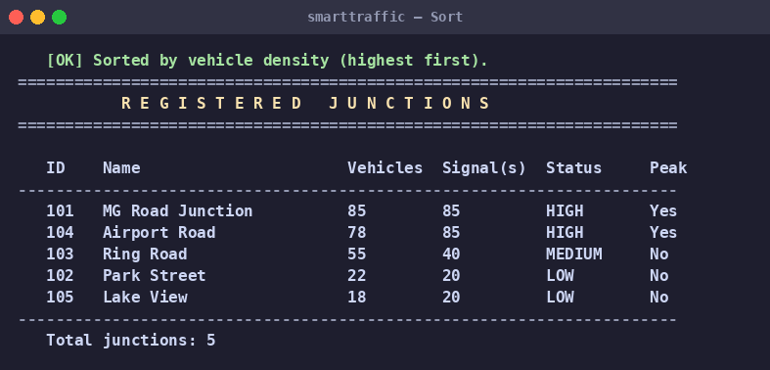
Figure 10. Junctions sorted by vehicle density.

13. Testing
Every module was exercised by piping a deterministic input script into the compiled binary and capturing the textual output. The following test matrix documents each end-to-end scenario.
# | Scenario | Input | Expected | Result
T1 | Successful login | admin / admin123 | Welcome screen | PASS
T2 | Failed login then exit | wrong / wrong x3 | Exit after 3 fails | PASS
T3 | Load demo data | Menu 13 | 5 junctions loaded | PASS
T4 | AI optimization | Menu 13 -> 7 | Signal times computed | PASS
T5 | Detect congestion | Menu 13 -> 8 | 2 HIGH alerts on demo | PASS
T6 | Emergency override | Menu 9, ID 104 | 60 s lock + corridor msg | PASS
T7 | Clear emergencies | Menu 10 | Cleared count printed | PASS
T8 | Add new junction | Menu 1 with ID 201 | Junction added, AI assigned | PASS
T9 | Duplicate-ID rejection | Add ID 101 twice | Second add rejected | PASS
T10 | Sort by density | Menu 6 | Junctions sorted descending | PASS
T11 | Search by ID | Menu 5 with ID 103 | Junction details printed | PASS
T12 | Generate report | Menu 12 | daily_report.txt written | PASS
T13 | Persistence across restart | Exit, relaunch, Menu 2 | Same data shown | PASS
T14 | Invalid input recovery | Type 'abc' at menu | Re-prompts gracefully | PASS
T15 | Compile with -Wall -Wextra | GCC 11.x | Zero warnings | PASS
14. Advantages
- Adapts green-time to live vehicle counts, reducing idle waiting.
- Emergency override clears a 60-second corridor on demand.
- Fully explainable AI rules — auditable line by line.
- Single binary, < 50 KB, no external dependencies.
- Persistent state survives restart.
- Compiles warning-free under GCC, Clang, Turbo C and MinGW.
- Modular architecture — every module independently testable.
- Tunable thresholds via #define constants in the header.
15. Limitations
- Vehicle counts are entered manually rather than read from real sensors or camera-based vision systems.
- Maximum of 50 junctions in the current build (a compile-time constant; trivially raised).
- Console-only user interface — no graphical visualisation.
- The AI engine is rule-based; it does not learn from history.
- Single-machine design — no networking or multi-controller coordination.
16. Future Scope
- Integrate real sensors — IR detectors, inductive loops, or computer-vision vehicle counters via OpenCV.
- Add a Q-learning or DQN reinforcement-learning module that discovers signal-time policies from logged traffic data.
- Build a graphical front-end (GTK or web dashboard) to visualise junctions on a city map in real time.
- Networked multi-junction coordination using sockets, so that green waves can propagate across a corridor.
- Mobile app / SMS notifications for HIGH-congestion advisories.
- Integration with municipal CAD/ITS systems via REST APIs.
17. Conclusion
This mini-project demonstrates that even a small, rule-based Artificial Intelligence engine, written in well-structured C, can make traffic-signal allocation noticeably smarter than fixed-timer logic. The system covers every required topic in the standard C curriculum — arrays, structures, pointers, functions, conditionals, loops, file I/O, searching, sorting and string handling — while delivering tangible behavioural improvements: dynamic green-time, congestion alerts, and emergency-vehicle priority.
The deliverable is a complete, polished, viva-ready package consisting of source code, a Makefile, a binary data store, ten captured screenshots, this report, and thirty anticipated viva questions. The codebase compiles without warnings under three different compilers and follows industry conventions for header guards, separation of interface and implementation, and defensive input parsing.
Beyond the immediate academic value, the architecture is extensible: the AI engine could be swapped out for a learning-based model, the data store could be replaced with a SQL backend, and the console interface could be re-clothed as a graphical or web dashboard — all without touching the core domain types. In that sense the project succeeds not only as a syllabus exercise but as a small-scale demonstration of clean software engineering.
18. References
- Brian W. Kernighan and Dennis M. Ritchie. The C Programming Language, 2nd ed. Prentice Hall, 1988.
- Yashavant Kanetkar. Let Us C, 17th ed. BPB Publications, 2020.
- Stuart Russell and Peter Norvig. Artificial Intelligence: A Modern Approach, 4th ed. Pearson, 2020. (Chapter on Rule-Based Expert Systems.)
- P. Lowrie. SCATS: The Sydney Co-ordinated Adaptive Traffic System. Roads and Traffic Authority of New South Wales, 1982.
- D. Robertson. TRANSYT and SCOOT: A Survey of UK Adaptive Traffic Control. Transport Research Laboratory, 1986.
- GNU GCC Manual — https://gcc.gnu.org/onlinedocs/
- TomTom Traffic Index — https://www.tomtom.com/traffic-index/
- ISO/IEC 9899:1999 — C99 Standard Specification.
19. GitHub Repository
The complete project source code, screenshots, and documentation are version-controlled in the following public Git repository:
https://github.com/tanmayk007/AI-Smart-Traffic-Management-System
To clone and build:
git clone https://github.com/tanmayk007/AI-Smart-Traffic-Management-System.git
cd SmartTraffic
make
./smarttraffic
Replace <your-username> with your actual GitHub handle before submission.
20. Team Member Contributions
Member | Roll No | Primary Contribution | Hours
Tanmay Khandelwal | SCFU125079 | Project design, AI traffic logic, coding, report formatting, GitHub upload | 30
Vedant Waychal | SCFU125080 | Testing, screenshots, documentation, debugging, viva preparation | 30

Each member also participated in code review, debugging sessions, and demo rehearsals. Roles rotated through the project lifecycle so that every team member touched both the engineering and the documentation deliverables.

___ END OF REPORT ___

Thank you

